**Practical session 3**

*For the practical parts of this lab (implementing programs, running them) please save the Python programs that you create and take screenshots of the execution (evaluation) of your programs. Commit (upload) all source code you create to your code repository.*

**Github:**

1) If you haven’t done so yet, please sign up for Github <https://github.com/>

2) Create a repository for your source code

3) Commit (upload) the code from week 1 to your repository

**Reminder on “Input”:**

Input(“query”) can only return Strings (words).

If we want to ask the user for a number , we need to modify the process of using input(“query”), as a number is different to a word, or as we say an integer (whole number) is different to a String (word). So we need to convert the String we get from the input(“query”) function into an integer (number).

To do so we use a typecast (Details in the next lecture), that basically transforms the written number from the String into our integer number. It works like this:

mynumber = int(input(“Please enter a number”))

The “int” bit is transforming the String we get from our input function into the integer number format.

Caveat: We must actually enter a number, like “17” as input, as a number-word, like “seventeen” could not be transformed into a number.

**Tasks:**

1) Write a program that asks for two numbers (Python has all the basic mathematical functions in place, like +,- etc.), adds them up and displays the result.

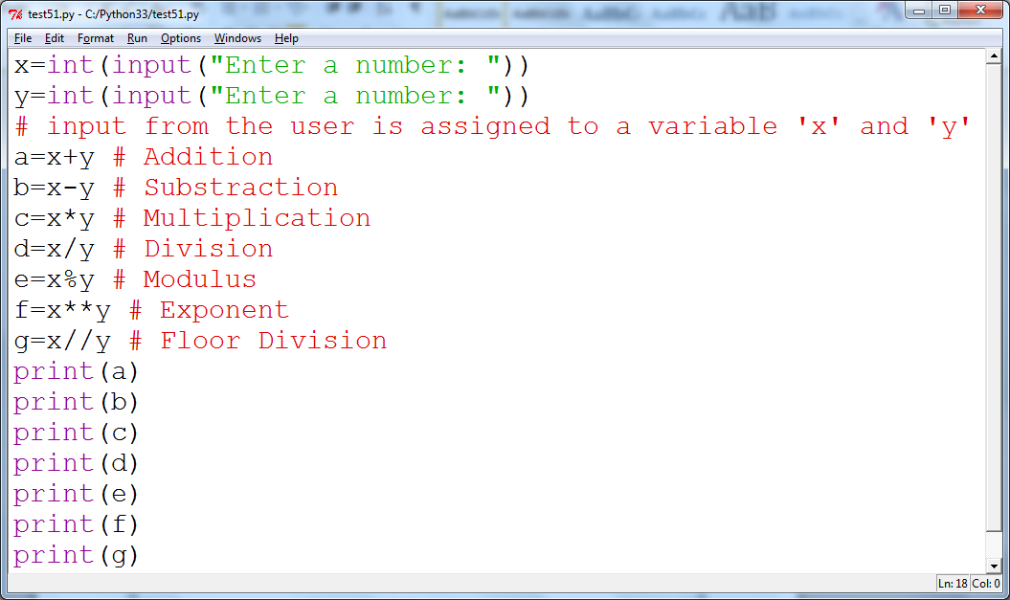

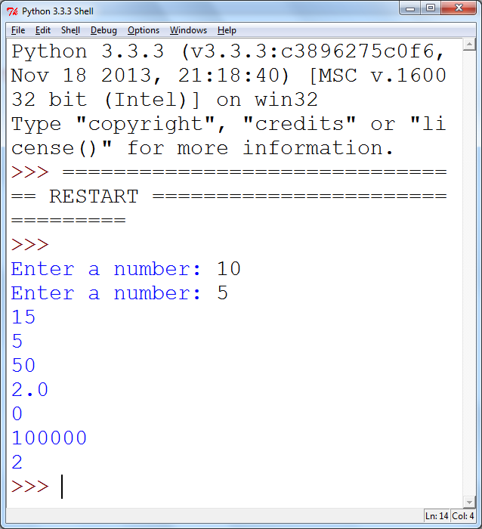

2) Answer the questions by implementing the code and run it.

1. What will the output be from the following code?

num = 4

num*=2

num1=num+2

num1+=3

print(num1)

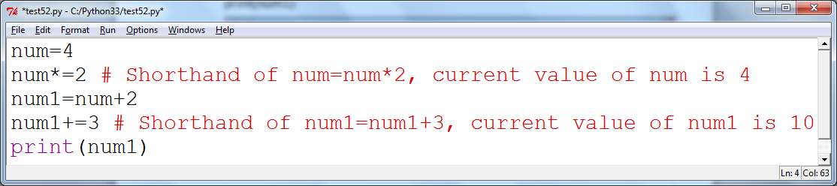

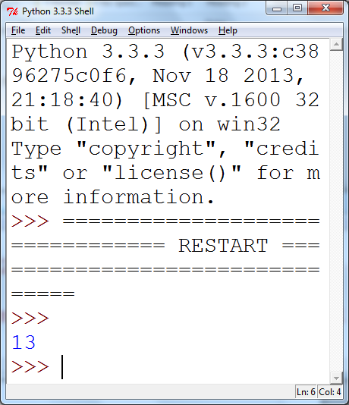

1. What do the following lines of code output? Why do they give a different answer?

print(2 / 3)

print(2 // 3)

// **Floor Division** The division of operands where the result is the quotient in which the digits after the decimal point are removed.

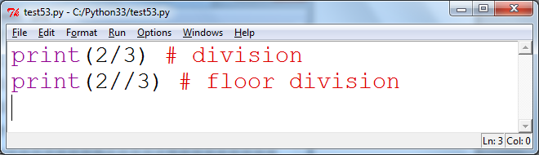

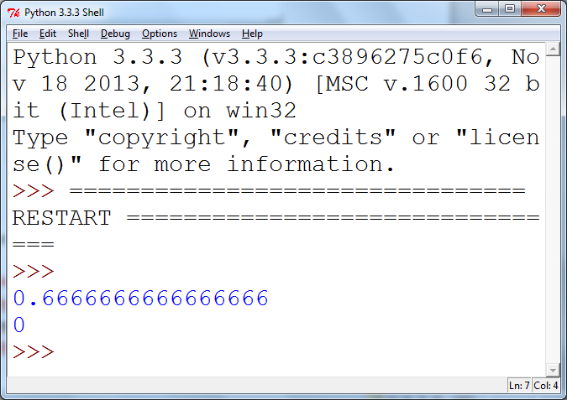

3) All of the variable names below can be used. But which of these is the better variable name to use?

A a Area AREA area areaOfRectangle AreaOfRectangle

4) Which of these variables names are not allowed in Python? (More than one might be wrong.)

apple APPLE Apple2 1Apple account number account_number account.number accountNumber fred Fred return return_value 5Return GreatBigVariable greatBigVariable great_big_variable great.big.variable